APPENDIX G
SCHOOL STREETS SCHEMES (TRANCHE 2)

Background
The school streets initiative under the TfL LSP programme has been successful in increasing the number of pedestrian journeys to school and reduced the impact of motor traffic in close proximity to schools. Engagement with schools has highlighted an interest from Head Teachers in taking forward further school street schemes and a second tranche of school streets schemes was applied for under TfL’s Active Travel Funding programme as follows:
- Roxbourne Primary School
- Pinner Wood School
- St John Fisher Catholic School
- Cedars Manor School
- Bentley Wood High School
- Camrose Primary School

On 28th January TfL awarded £200k for 5 of the school streets and an additional £40k was subsequently awarded granting Harrow a total of £240k to take forward all six schemes proposed.
Extent of schemes
The plans show the extent of proposals around the six schools. The dots indicate the entry / exit points to the restricted streets.

Roxbourne Primary School
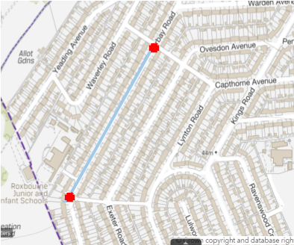 | Rayners Lane ward  Restrictions in Torbay Road between Widdicombe Avenue and Capthorne Avenue

Pinner Wood School
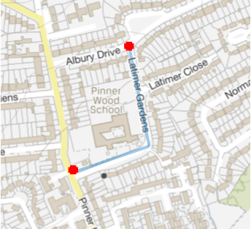 | Pinner ward  Restrictions in Latimer Gardens

St. John Fisher Catholic Primary School
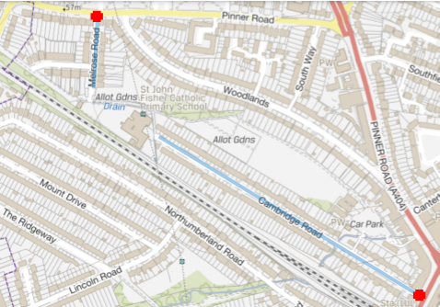 | Headstone North ward  Restrictions in Cambridge Road and Melrose Road

Cedars Manor School
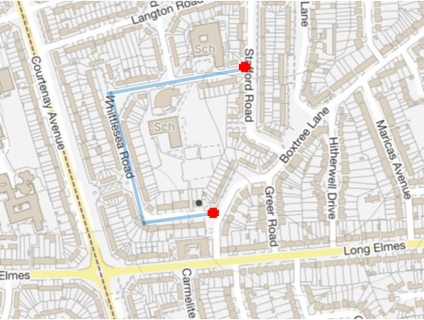 | Harrow Weald ward  Restrictions in Whittlesea Road

Bentley Wood High School
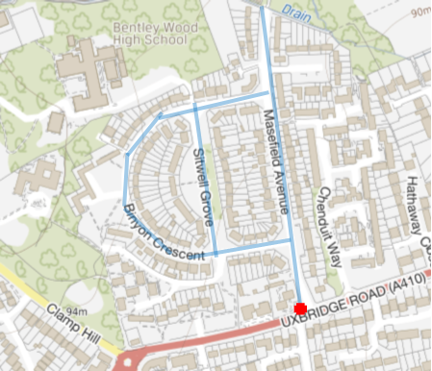 | Stanmore Park ward  Restrictions in Masefield Avenue, Bridges Road, Stilwell Grove, Binyon Crescent, Brockhurst Close, Flecker Close

Camrose Primary School
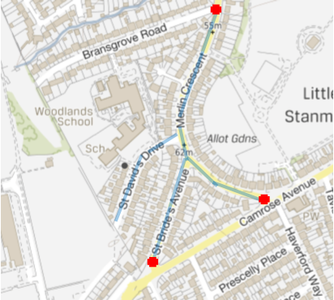 | Edgware ward  Restrictions in St David’s Drive, St Bride’s Avenue and Merlin Crescent (between Camrose Avenue and Bransgrove Road)

Pubic consultation

During April and May 2021 a public engaagement exercise was undertaken on the second tranche of proposed school streets schemes. A public engagement portal was used to provide details of the proposals and to receive feedback from the public.

Leaflets were circulated to all local residents in the immediate vicinity of the schools to highlight the consultation and engagement portal and encourage participation.

The results of the engagement for each school are reported here.

Roxbourne Primary School – public engagaement results

1. Do you live / work in the school streets?
 | Total | Very negative | Negative | Neutral | Positive | Very positive
No | 21 | 62% | 10% | 5% | 0% | 24%
Yes - I live there | 27 | 44% | 7% | 7% | 19% | 22%
Yes - I work there | 2 | 100% | 0% | 0% | 0% | 0%
Yes - my child goes to school here | 3 | 33% | 33% | 0% | 0% | 33%
Yes - I have a business there | 1 | 0% | 0% | 0% | 0% | 0%
Yes - I work at the school there | 1 | 0% | 0% | 0% | 0% | 100%
Yes - I work at a GP surgery /health centre | 0 | 0% | 0% | 0% | 0% | 0%
Yes - I run/attend a place of worship | 0 | 0% | 0% | 0% | 0% | 0%
Other | 0 | 0% | 0% | 0% | 0% | 0%

2. If No, what is your connection to the school streets?
 | Total | Very negative | Negative | Neutral | Positive | Very positive
Live locally | 17 | 41% | 18% | 6% | 0% | 35%
Have a child that attends the school | 8 | 38% | 38% | 13% | 0% | 13%
Commute through the school streets | 7 | 71% | 14% | 0% | 0% | 14%
Live in Harrow | 13 | 62% | 15% | 8% | 0% | 15%
Work in Harrow | 1 | 0% | 0% | 0% | 0% | 100%
Work at a GP surgery / Health Centre | 0 | 0% | 0% | 0% | 0% | 0%
Run/attend a place of worship | 2 | 50% | 0% | 0% | 0% | 50%
I work at the school there | 1 | 100% | 0% | 0% | 0% | 0%
Other | 0 | 0% | 0% | 0% | 0% | 0%

3. If you have a child at the school, what is your main mode of travel to school?
Walking | 11 | 52%
Cycling | 0 | 0%
Car / motorbike | 8 | 38%
Public transport | 1 | 5%
Other | 1 | 5%
Total | 21

4. How do you feel about this proposal?
Very negative | 27 | 51%
Negative | 5 | 9%
Neutral | 3 | 6%
Positive | 5 | 9%
Very positive | 13 | 25%
Total | 53

5. Why have you come to this decision?
Reason | Total | Very negative | Negative | Neutral | Positive | Very positive
Road safety | 20 | 25% | 5% | 0% | 15% | 55%
Traffic / Parking congestion | 36 | 50% | 8% | 6% | 11% | 25%
live / work / exercise | 18 | 50% | 6% | 11% | 11% | 22%
Active travel - walking / cycling / scooting | 5 | 20% | 0% | 0% | 0% | 80%
Speeding vehicles | 9 | 22% | 0% | 0% | 11% | 67%
Air quality / public health | 10 | 30% | 0% | 0% | 0% | 70%
Impact on surrounding roads | 26 | 73% | 8% | 4% | 4% | 12%
Access for disabled people | 8 | 100% | 0% | 0% | 0% | 0%
Other | 10 | 80% | 10% | 10% | 0% | 0%

6. Do you have any other comments?
 | Comments Summarised | No.
1 | Not in favour of the scheme | 11
2 | This scheme will push more traffic and congestion onto surrounding roads | 8
3 | Support the proposal will improve safety and encourage walking | 7
4 | Include Widdicombe - and the section of Torbay road above Dunster Way | 6
5 | Will affect deliveries – children with disabilites - relatives | 6
6 | No ANPR – money making exercise – scheme waste of time - expensive | 4
7 | Permits for childminders | 2
8 | No evidence of any accidents | 2
9 | Supported cycle lanes should not have been scrapped | 1
10 | Free permits wont last for long before charges apply | 1
11 | The Newton Farm scheme has caused issues in Kings Road | 1
12 | Enforce waiting restrictions | 1
13 | Promote sustainable modes of transport or other options | 1
14 | All the school entrances could be covered by protecting Waverley Avenue alone. | 1
15 | Improve local transport infrastructure to support modal shift | 1

Pinner Wood School – public engagaement results

1. Do you live / work in the school streets?
 | Total | Very negative | Negative | Neutral | Positive | Very positive
No | 60 | 60% | 12% | 7% | 2% | 20%
Yes - I live there | 24 | 38% | 8% | 4% | 25% | 25%
Yes - I work there | 3 | 67% | 33% | 0% | 0% | 0%
Yes - my child goes to school here | 50 | 28% | 4% | 10% | 12% | 46%
Yes - I have a business there | 0 | 0% | 0% | 0% | 0% | 0%
Yes - I work at the school there | 2 | 50% | 0% | 50% | 0% | 0%
Yes - I work at a GP surgery /health centre | 0 | 0% | 0% | 0% | 0% | 0%
Yes - I run/attend a place of worship | 0 | 0% | 0% | 0% | 0% | 0%
Other | 13 | 69% | 15% | 0% | 0% | 15%

2. If No, what is your connection to the school streets?
 | Total | Very negative | Negative | Neutral | Positive | Very positive
Live locally | 53 | 70% | 6% | 6% | 2% | 17%
Have a child that attends the school | 38 | 55% | 11% | 8% | 5% | 21%
Commute through the school streets | 10 | 80% | 0% | 10% | 0% | 10%
Live in Harrow | 23 | 52% | 9% | 13% | 0% | 26%
Work in Harrow | 3 | 100% | 0% | 0% | 0% | 0%
Work at a GP surgery / Health Centre | 1 | 100% | 0% | 0% | 0% | 0%
Run/attend a place of worship | 2 | 50% | 0% | 0% | 0% | 50%
I work at the school there | 6 | 83% | 0% | 0% | 0% | 17%
Other | 0 | 0% | 0% | 0% | 0% | 0%

3. If you have a child at the school, what is your main mode of travel to school?
Walking | 48 | 52%
Cycling | 5 | 5%
Car / motorbike | 36 | 39%
Public transport | 3 | 3%
Other | 1 | 1%
Total | 93

4. How do you feel about this proposal?
Very negative | 69 | 50%
Negative | 12 | 9%
Neutral | 10 | 7%
Positive | 10 | 7%
Very positive | 38 | 27%
Total | 139

5. Why have you come to this decision?
Reason | Total | Very negative | Negative | Neutral | Positive | Very positive
Road safety | 68 | 29% | 7% | 6% | 9% | 49%
Traffic / Parking congestion | 108 | 48% | 9% | 8% | 8% | 26%
live / work / exercise | 29 | 48% | 7% | 3% | 0% | 41%
Active travel - walking / cycling / scooting | 18 | 22% | 0% | 0% | 6% | 72%
Speeding vehicles | 29 | 28% | 0% | 3% | 10% | 59%
Air quality / public health | 41 | 39% | 2% | 2% | 10% | 46%
Impact on surrounding roads | 75 | 69% | 11% | 9% | 5% | 5%
Access for disabled people | 12 | 58% | 0% | 0% | 0% | 42%
Other | 7 | 86% | 14% | 0% | 0% | 0%

6. Do you have any other comments?
 | Comments Summarised | No.
1 | This scheme will push more traffic and congestion onto surrounding roads,like Albury Drive or Pinner Hil; | 41
2 | Support the proposal will improve safety and encourage walking | 19
3 | Not in favour of the scheme,will create problems elsewhere | 15
4 | Enforce parking restrictions / more restrictions / consider drop off zone | 8
5 | Improve local transport infrastructure to support modal shift | 4
6 | The Council should consider extending the scheme wider to include Albury Drive and Pinner Hill | 5
7 | Hours of operation are not long enough | 5
8 | Promote sustainable modes of transport or other options | 3
9 | Will affect deliveries - contractors- carers-gardeners- family members – parcel deliveries | 4
10 | No ANPR – money making exercise – scheme waste of time – expensive to run | 2
11 | Include Welch Place in the scheme | 2
12 | Put permeant camera to enforce school zig zags instead | 2
13 | Childminders should be excempt | 1
14 | Free permits wont last for long before charges apply | 1
15 | The scheme is inconvenient I have medical condition and wont be able to drop my children off outside the school. | 1
16 | Offer free permits to parents who drive a long way to the school | 1

St John Fisher School – public engagaement results

1. Do you live / work in the school streets?
 | Total | Very negative | Negative | Neutral | Positive | Very positive
No | 42 | 48% | 5% | 14% | 12% | 21%
Yes - I live there | 57 | 32% | 16% | 5% | 18% | 30%
Yes - I work there | 2 | 100% | 0% | 0% | 0% | 0%
Yes - my child goes to school here | 16 | 25% | 0% | 13% | 13% | 50%
Yes - I have a business there | 2 | 0% | 0% | 0% | 0% | 0%
Yes - I work at the school there | 0 | 0% | 0% | 0% | 0% | 0%
Yes - I work at a GP surgery /health centre | 2 | 0% | 0% | 0% | 0% | 0%
Yes - I run/attend a place of worship | 2 | 0% | 0% | 0% | 0% | 0%
Other | 0 | 0% | 0% | 0% | 0% | 0%

2. If No, what is your connection to the school streets?
 | Total | Very negative | Negative | Neutral | Positive | Very positive
Live locally | 35 | 51% | 6% | 14% | 11% | 17%
Have a child that attends the school | 11 | 18% | 0% | 36% | 18% | 27%
Commute through the school streets | 8 | 63% | 0% | 13% | 13% | 13%
Live in Harrow | 14 | 64% | 0% | 7% | 14% | 14%
Work in Harrow | 2 | 0% | 0% | 0% | 50% | 50%
Work at a GP surgery / Health Centre | 0 | 0% | 0% | 0% | 0% | 0%
Run/attend a place of worship | 2 | 100% | 0% | 0% | 0% | 0%
I work at the school there | 5 | 40% | 20% | 0% | 20% | 20%
Other | 0 | 0% | 0% | 0% | 0% | 0%

3. If you have a child at the school, what is your main mode of travel to school?
Walking | 24 | 60%
Cycling | 3 | 8%
Car / motorbike | 9 | 23%
Public transport | 2 | 5%
Other | 2 | 5%
Total | 40

4. How do you feel about this proposal?
Very negative | 45 | 39%
Negative | 12 | 10%
Neutral | 11 | 9%
Positive | 15 | 13%
Very positive | 33 | 28%
Total | 116

5. Why have you come to this decision?
Reason | Total | Very negative | Negative | Neutral | Positive | Very positive
Road safety | 52 | 15% | 6% | 6% | 21% | 52%
Traffic / Parking congestion | 77 | 31% | 9% | 8% | 16% | 36%
live / work / exercise | 32 | 38% | 0% | 3% | 19% | 41%
Active travel - walking / cycling / scooting | 18 | 6% | 0% | 11% | 39% | 44%
Speeding vehicles | 28 | 18% | 4% | 4% | 21% | 54%
Air quality / public health | 42 | 19% | 7% | 0% | 17% | 57%
Impact on surrounding roads | 46 | 59% | 15% | 9% | 2% | 15%
Access for disabled people | 15 | 53% | 7% | 13% | 7% | 20%
Other | 21 | 67% | 14% | 14% | 0% | 5%

6. Do you have any other comments?
 | Comments Summarised | No.
1 | This scheme will push more traffic and congestion onto surrounding roads, particularly Woodlands | 20
2 | Support the proposal will improve safety and encourage walking | 16
3 | Will affect deliveries - contractors- carers-deliveries- family members – visitors | 11
4 | Not in favour of the scheme to restrictive | 10
5 | Manage the Cambridge Road car park for drop off times park and stride | 8
6 | Enforce parking restrictions / more restrictions | 7
7 | Move the cameras further up the road past the car park - or have 2 cameras | 6
8 | Parents leave engines running whilst they pick up children causing pollution park across driveways | 5
9 | People will drop off in Cambridge Road car park | 4
10 | No ANPR – money making exercise – scheme waste of time - expensive | 4
11 | Scheme should opertate for longer | 4
12 | Improve local transport infrastructure to support modal shift | 2
13 | Free permits wont last for long before charges apply | 1
14 | Include Woodlands, Thrush Green and South Way in scheme | 1
15 | Permits should be for residents only and not staff of the school | 1

Cedars Manor School – public engagaement results

1. Do you live / work in the school streets?
 | Total | Very negative | Negative | Neutral | Positive | Very positive
No | 12 | 50% | 8% | 0% | 0% | 42%
Yes - I live there | 14 | 64% | 0% | 0% | 14% | 21%
Yes - I work there | 7 | 0% | 0% | 0% | 0% | 0%
Yes - my child goes to school here | 10 | 80% | 0% | 10% | 0% | 10%
Yes - I have a business there | 1 | 0% | 0% | 0% | 0% | 0%
Yes - I work at the school there | 0 | 0% | 0% | 0% | 0% | 0%
Yes - I work at a GP surgery /health centre | 2 | 0% | 0% | 0% | 0% | 0%
Yes - I run/attend a place of worship | 0 | 0% | 0% | 0% | 0% | 0%
Other | 3 | 67% | 33% | 0% | 0% | 0%

2. If No, what is your connection to the school streets?
 | Total | Very negative | Negative | Neutral | Positive | Very positive
Live locally | 17 | 53% | 6% | 6% | 6% | 29%
Have a child that attends the school | 3 | 67% | 0% | 0% | 0% | 33%
Commute through the school streets | 2 | 100% | 0% | 0% | 0% | 0%
Live in Harrow | 9 | 78% | 0% | 0% | 0% | 22%
Work in Harrow | 1 | 0% | 0% | 0% | 0% | 100%
Work at a GP surgery / Health Centre | 1 | 0% | 0% | 0% | 0% | 0%
Run/attend a place of worship | 0 | 0% | 0% | 0% | 0% | 0%
I work at the school there | 1 | 0% | 100% | 0% | 0% | 0%
Other | 0 | 0% | 0% | 0% | 0% | 0%

3. If you have a child at the school, what is your main mode of travel to school?
Walking | 9 | 53%
Cycling | 1 | 6%
Car / motorbike | 6 | 35%
Public transport | 1 | 6%
Other | 0 | 0%
Total | 17

4. How do you feel about this proposal?
Very negative | 27 | 56%
Negative | 5 | 10%
Neutral | 3 | 6%
Positive | 3 | 6%
Very positive | 10 | 21%
Total | 48

5. Why have you come to this decision?
Reason | Total | Very negative | Negative | Neutral | Positive | Very positive
Road safety | 21 | 33% | 0% | 10% | 10% | 48%
Traffic / Parking congestion | 30 | 60% | 7% | 3% | 10% | 20%
live / work / exercise | 14 | 57% | 0% | 0% | 7% | 36%
Active travel - walking / cycling / scooting | 7 | 14% | 0% | 14% | 14% | 57%
Speeding vehicles | 10 | 30% | 10% | 0% | 10% | 50%
Air quality / public health | 10 | 0% | 0% | 0% | 0% | 0%
Impact on surrounding roads | 23 | 74% | 4% | 9% | 9% | 4%
Access for disabled people | 9 | 67% | 22% | 0% | 11% | 0%
Other | 4 | 50% | 50% | 0% | 0% | 0%

6. Do you have any other comments?
 | Comments Summarised | No.
1 | This scheme will push more traffic onto surrounding roads | 7
2 | Support the proposal will improve safety and encourage walking | 6
3 | Not in favour of the scheme to restrictive | 6
4 | Worried about Kingsley staff and peripatetic therapists and other professionals not getting permits | 5
5 | Will affect deliveries - contractors- carers-mini cabs / taxis- family members - parcel deliveries | 4
6 | Cedars Centre need access for mid wifes and preschool children and sensory room particularly for families who have a child with a disability. | 2
7 | Worried about Cedar Manor school staff not getting permits | 2
8 | Worried about access for taxis for elderly | 1
9 | We need to reduce pollution at school gates for the health of our children | 1
10 | Mencap clients rely on bus services to bring them to and fro the centre and need to stop outside the centre for drop offs and pick ups. | 1
11 | No ANPR – money making exercise – scheme waste of time | 1
12 | Use money for promoting sustainable modes of transport or other options | 1
13 | Improve local transport infrastructure to support modal shift | 1
14 | Hours of operation in am and pm should be the same | 1
15 | Use money for promoting sustainable modes of transport or other options | 1

Bentley Wood High School – public engagaement results

1. Do you live / work in the school streets?
 | Total | Very negative | Negative | Neutral | Positive | Very positive
No | 49 | 55% | 14% | 4% | 2% | 24%
Yes - I live there | 48 | 15% | 4% | 10% | 8% | 63%
Yes - I work there | 0 | 0% | 0% | 0% | 0% | 0%
Yes - my child goes to school here | 7 | 43% | 14% | 0% | 0% | 43%
Yes - I have a business there | 1 | 0% | 0% | 0% | 0% | 0%
Yes - I work at the school there | 1 | 0% | 0% | 0% | 0% | 100%
Yes - I work at a GP surgery /health centre | 0 | 0% | 0% | 0% | 0% | 0%
Yes - I run/attend a place of worship | 0 | 0% | 0% | 0% | 0% | 0%
Other | 14 | 64% | 7% | 7% | 7% | 14%

2. If No, what is your connection to the school streets?
 | Total | Very negative | Negative | Neutral | Positive | Very positive
Live locally | 40 | 63% | 13% | 8% | 3% | 15%
Have a child that attends the school | 3 | 67% | 33% | 0% | 0% | 0%
Commute through the school streets | 11 | 45% | 9% | 0% | 9% | 36%
Live in Harrow | 24 | 63% | 4% | 4% | 0% | 29%
Work in Harrow | 6 | 67% | 0% | 0% | 0% | 33%
Work at a GP surgery / Health Centre | 0 | 0% | 0% | 0% | 0% | 0%
Run/attend a place of worship | 2 | 100% | 0% | 0% | 0% | 0%
I work at the school there | 1 | 0% | 0% | 100% | 0% | 0%
Other | 8 | 63% | 25% | 0% | 0% | 13%

3. If you have a child at the school, what is your main mode of travel to school?
Walking | 8 | 28%
Cycling | 3 | 10%
Car / motorbike | 13 | 45%
Public transport | 4 | 14%
Other | 1 | 3%
Total | 29

4. How do you feel about this proposal?
Very negative | 46 | 39%
Negative | 11 | 9%
Neutral | 9 | 8%
Positive | 6 | 5%
Very positive | 46 | 39%
Total | 118

5. Why have you come to this decision?
Reason | Total | Very negative | Negative | Neutral | Positive | Very positive
Road safety | 59 | 17% | 10% | 7% | 5% | 61%
Traffic / Parking congestion | 86 | 36% | 8% | 8% | 6% | 42%
live / work / exercise | 35 | 0% | 0% | 0% | 0% | 0%
Active travel - walking / cycling / scooting | 15 | 20% | 7% | 0% | 7% | 67%
Speeding vehicles | 25 | 0% | 0% | 0% | 0% | 0%
Air quality / public health | 36 | 22% | 8% | 6% | 3% | 61%
Impact on surrounding roads | 58 | 0% | 0% | 0% | 0% | 0%
Access for disabled people | 9 | 0% | 0% | 0% | 0% | 0%
Other | 10 | 70% | 10% | 20% | 0% | 0%

6. Do you have any other comments?
 | Comments Summarised | No.
1 | Not in favour of the scheme to restrictive | 23
2 | Support the proposal will improve safety and encourage walking | 21
3 | This scheme will push more traffic onto surrounding roads including Clamp Hill and Uxbridge Road | 19
4 | Will affect deliveries - contractors- carers-mini cabs / taxis- family members – parcel deliveries | 11
5 | Hours of operation are not long enough | 8
6 | Chenduit Way should be in the scheme as people park there and walk through alleyway. | 8
7 | The estate is gridlocked at school times | 8
8 | Parents should use the Clamp Hill to drop off no reason to use local streets. School should close Bridges Road entrance | 7
9 | No ANPR – money making exercise – scheme waste of time | 6
10 | Use money for promoting sustainable modes of transport or other options | 3
11 | We will have to pay for permits in the future | 2
12 | Consider one way streets or speed humps instead | 2
13 | School should only take children from local catchment area – supply more school buses | 2
14 | Improve local transport infrastructure to support modal shift | 1
15 | Clamp Hill drop off is congested and there are road safety issues | 1

Camrose Primary School – public engagaement results

1. Do you live / work in the school streets?
 | Total | Very negative | Negative | Neutral | Positive | Very positive
No | 25 | 72% | 4% | 0% | 0% | 24%
Yes - I live there | 14 | 29% | 14% | 14% | 7% | 36%
Yes - I work there | 17 | 76% | 6% | 6% | 12% | 0%
Yes - my child goes to school here | 10 | 70% | 20% | 0% | 0% | 10%
Yes - I have a business there | 0 | 0% | 0% | 0% | 0% | 0%
Yes - I work at the school there | 6 | 83% | 0% | 17% | 0% | 0%
Yes - I work at a GP surgery /health centre | 0 | 0% | 0% | 0% | 0% | 0%
Yes - I run/attend a place of worship | 0 | 0% | 0% | 0% | 0% | 0%
Other | 3 | 67% | 33% | 0% | 0% | 0%

2. If No, what is your connection to the school streets?
 | Total | Very negative | Negative | Neutral | Positive | Very positive
Live locally | 15 | 40% | 27% | 0% | 0% | 33%
Have a child that attends the school | 11 | 91% | 0% | 0% | 0% | 9%
Commute through the school streets | 7 | 100% | 0% | 0% | 0% | 0%
Live in Harrow | 14 | 64% | 0% | 0% | 0% | 36%
Work in Harrow | 5 | 80% | 0% | 0% | 0% | 20%
Work at a GP surgery / Health Centre | 1 | 100% | 0% | 0% | 0% | 0%
Run/attend a place of worship | 1 | 100% | 0% | 0% | 0% | 0%
I work at the school there | 4 | 100% | 0% | 0% | 0% | 0%
Other | 4 | 100% | 0% | 0% | 0% | 0%

3. If you have a child at the school, what is your main mode of travel to school?
Walking | 7 | 24%
Cycling | 1 | 3%
Car / motorbike | 18 | 62%
Public transport | 1 | 3%
Other | 2 | 7%
Total | 29

4. How do you feel about this proposal?
Very negative | 44 | 64%
Negative | 7 | 10%
Neutral | 3 | 4%
Positive | 3 | 4%
Very positive | 12 | 17%
Total | 69

5. Why have you come to this decision?
Reason | Total | Very negative | Negative | Neutral | Positive | Very positive
Road safety | 16 | 25% | 6% | 6% | 13% | 50%
Traffic / Parking congestion | 39 | 62% | 8% | 5% | 8% | 18%
live / work / exercise | 18 | 61% | 0% | 6% | 6% | 28%
Active travel - walking / cycling / scooting | 6 | 17% | 0% | 0% | 0% | 83%
Speeding vehicles | 5 | 20% | 0% | 20% | 0% | 60%
Air quality / public health | 13 | 15% | 0% | 0% | 8% | 77%
Impact on surrounding roads | 32 | 69% | 16% | 9% | 0% | 6%
Access for disabled people | 15 | 93% | 7% | 0% | 0% | 0%
Other | 7 | 71% | 14% | 14% | 0% | 0%

6. Do you have any other comments?
 | Comments Summarised | No.
1 | Not in favour of the scheme to restrictive | 10
2 | Will create grid lock and parking issues in the surrounding areas | 8
3 | Worried about Woodlands staff not getting permits | 8
4 | Disabled pupils at Woodlands should be allowed to be picked up and dropped off by parents or carers. They should be excempt from the scheme | 8
5 | Support the proposal will improve safety and encourage walking | 5
6 | No ANPR – money making exercise – scheme waste of time | 3
7 | Worried about charging for permit in future | 2
8 | Will help stop people obstructing driveways | 1
9 | I live a long way from the school and need to drive my child there | 1
10 | The zone boundary is too large | 1
11 | Spend money on promoting road safety around school instead | 1
12 | Consider one way streets instead | 1
13 | Parking controls should be introduced throughout the area | 1
14 | Supported cycle lanes should not have been scrapped | 1
15 | Will affect deliveries – contractors- taxis – family members - parcels | 1

